**Founding “Values” in US History**

Over the first few class periods, we have brainstormed a list of values that are important to Americans--democracy, freedom, equality, and justice to name a few. These values are written about in documents, spoken about in our society and culture, and are often taught in social studies classes throughout your K-12 education as “founding values.” Are they indeed founding values? Where do you see them in society? Who is allowed to access these freedoms in 2021? After considering these questions and completing further research, your task is to address the driving question below:

**Driving Question: To what extent is the United States living up to its founding values?**

You will need to research and decide with your partner(s) on which values to focus. Here are some examples you may want to use as evidence in your response:

The Story of Voting Rights (discussed in-class)

The Bill of Rights and the Constitution

John Winthrop’s City Upon a Hill Speech

Barack Obama’s More Perfect Union Speech

Once you have decided on 3-5 values (or freedoms), you should find examples of this value in action--either being upheld or violated.

**The Format**

1. Create a presentation (I suggest Google Slides) or a Podcast, or other ideas?
2. Your presentation should address the driving question directly.
3. Use evidence from your research to support your response. Images are always a good idea if you are doing a visual presentation.

Presentations: Friday, September 10th

**The Writing Part of this assignment**

* After we hear from each group, you will be asked to respond to the driving question, individually. You will be able to use any notes you have taken throughout this process. The writing will take place in class and we will review and create an outline ahead of time to help you organize your thoughts.

In-class essay: Friday, September 17th

**Outcomes**

Content Understanding and [Writing Argument](https://docs.google.com/document/d/1L-bMfi6v8DRqklqfdWiptNEkTYN_kNOcLPzq2beCJR8/edit)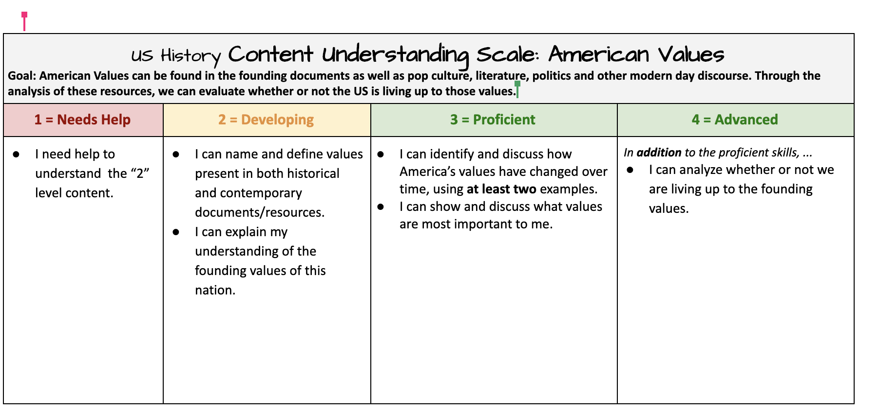

| **Interactive**  **Notes** | **Name: Dessa Shapiro**  **Date: 9/1/21**  **Class/Period: 6th**  **Topic: US history** |
| --- | --- |
| **Essential Question:** To what extent is the United States living up to its founding values?  - Democracy/ self-goverment | |
| **Source (APA format)** | |
| **Questions/ comments**  but the struggle still continued and It was a long time until a lot of the slaves learned about their own right to freedom ( juneteenth)   * Information spread less quickly back then.   Democracy:  history/ why is it a funding value:  **Slide 1**  Democracy is one of the main components of the creation of the United States as an independent country. The US was mainly built on the desire for independence from the British taxes and overall authority. The country’s leaders wanted to implement a form of government that was synchronized with their views. And so a representative democracy was formed, with the objective of including every citizen in the politics and government decisions.  **Slide 2**  The US is defined as a representative democracy meaning that elected persons make decisions and implement policies for the group, unlike a direct democracy in which the people decide on policies without any intermediary. But are we a democracy at all ?and where are we ever? From the beginning, the idea and implementation of democracy have rested in a grey area. African American people and women were not allowed to participate in government systems, whether that be running for office, voting, or anything else(excluding about 70% of the population from the government). We can see these restrictions in The constitution, the United States’ main document of law and government at the time, which excludes women entirely. There was also the existence of slavery and there were many people excluded from the terms of citizenship. And this would not be fixed until the Civil Rights Act of 1964 voting rights act in 1965(130 years sincedemocracy was first implemented). and even then there was inequality in regards to voting or other government activities.  Slide 3:  So, has democracy changed from then till now? And are we living in a truly democratic system? The answer is not so simple. This survey shows how a group of US citizens think the US democracy is holing up to certain aspects. As you can see, the results for each aspect greatly vary. But none of them were said to be fully met. And this graph, composed of 20 years of research, by standford shows the overall public support of an idea to the likelihood of Congress passing a law that reflects these ideas. As you can see the 90% of the population has practically no political sway. Whereas the rich, society elites have I much higher chance of getting laws and decisions passed that are congruent with their views/opinions. I’ll end with this quote from Brendan Nyhan, a professor of government at Dartmouth “It’s not perfect, but it has stronger and more resilient institutions than other countries that have had democratic backsliding or turning toward authoritarianism.”  uh·thaw·ruh·**teh**·ree·uh·ni·zm | **Main Ideas/Details/Answers/Explanation/Analysis**  N At the end of the civil war in 1865 the 13th amendment of the united states was made ¨Slavery was declared illegal in every part of the newly restored Union. African-Americans across the nation were free.¨  Since there was still slavery happening throughout the country congress decided to create two more Amendments. ¨the fourteenth in 1868, which guaranteed African Americans citizenship and protection under the law, and the fifteenth in 1870, which granted all male citizens full constitutional rights.¨  ——————————————————————--Change in topic:  **Def.**  **“a system of government by the whole population or all the eligible members of a state, typically through elected representatives.”**  **Def: republic**  **a state in which supreme power is held by the people and their elected representatives, and which has an elected or nominated president rather than a monarch.**  **Difference: In a direct democracy the citizens are making their own laws, while in a republic, the citizens choose a few people to make laws on their behalf.**  The United States wanted its freedom and independence from Britain, and to do this they needed not only to legally be recognized as an independent country but to implement a form of government that was synchronized with their views. And so a representative democracy was formed, with the objective of including every citizen in the politics and government decisions.  But was this system truly inclusive?  Are the decisions made and laws put into place, supported by the citizens of this country?  **Evidence 1**(argument)**:**  “founding generation was deeply skeptical of what it called “pure” democracy and defended the American experiment as “wholly republican.” To make this a rejection of democracy misses how the idea of government by the people, including both a democracy and a republic, was understood when the Constitution was drafted and ratified. It misses, too, how we understand the idea of democracy today.”  “At the time of the founding, a narrow vision of the people prevailed. Black people were largely excluded from the terms of citizenship, and slavery was a reality, even when frowned upon, that existed alongside an insistence on self-government.  America could not be considered a truly popular government until the passage of the Civil Rights Act of 1964 and the Voting Rights Act of 1965, which commanded equal citizenship for Black Americans.”  **Evidence 2:**  fewer than two-thirds said other important standards of democracy were being met: no interference with the press and respect for judicial independence by elected branches of government. And a minority said the United States was succeeding at equal rights or basic behavioral norms of civil discourse.    “It’s not perfect, but it has stronger and more resilient institutions than other countries that have had democratic backsliding or turning toward authoritarianism.”      The graph is an estimate but fairly accurate  **Wikipedia Contributors. (2021, September 6). Direct democracy. Retrieved September 8, 2021, from Wikipedia website:** [**https://en.wikipedia.org/wiki/Direct_democracy#:~:text=In%20a%20representative%20democracy%20people,on%20policies%20without%20any%20intermediary.&text=A%20popular%20referendum%20empowers%20citizens,a%20vote%20by%20the%20citizens**](https://en.wikipedia.org/wiki/Direct_democracy#:~:text=In%20a%20representative%20democracy%20people,on%20policies%20without%20any%20intermediary.&text=A%20popular%20referendum%20empowers%20citizens,a%20vote%20by%20the%20citizens)**.**  **Huntzinger, J. (2018). Why The Founding Fathers Despised Democracy. Retrieved September 8, 2021, from Townhall website:** [**https://finance.townhall.com/columnists/jimhuntzinger/2018/12/07/why-the-founding-fathers-despised-democracy-n2537155**](https://finance.townhall.com/columnists/jimhuntzinger/2018/12/07/why-the-founding-fathers-despised-democracy-n2537155)  What Is a Democracy? [ushistory.org]. (2021). Retrieved September 8, 2021, from Ushistory.org website: <https://www.ushistory.org/gov/1c.asp>  Wikipedia Contributors. (2021, September 8). Democracy in America. Retrieved September 8, 2021, from Wikipedia website: <https://en.wikipedia.org/wiki/Democracy_in_America#:~:text=Democracy%20in%20America%20was%20published,impact%20on%20the%20French%20population>.  ‌  ‌  **‌**  **‌**  Summary: |

**Slide 1**

Democracy is one of the main components of the creation of the United States as an independent country. The US was mainly built on the desire for independence from the British taxes and overall authority. The country’s leaders wanted to implement a form of government that was synchronized with their views. And so a representative democracy was formed, with the objective of including every citizen in the politics and government decisions.

**Slide 2**

The US is defined as a representative democracy meaning that elected persons make decisions and implement policies for the group, unlike a direct democracy in which the people decide on policies without any intermediary. But are we a democracy at all? and where are we ever? From the beginning, the idea and implementation of democracy have rested in a grey area. African American people and women were not allowed to participate in government systems, whether that be running for office, voting, or anything else(excluding about 70% of the population from the government). We can see these restrictions in The constitution, the United States’ main document of law and government at the time, which excludes women entirely. There was also the existence of slavery and there were many people excluded from the terms of citizenship. And this would not be fixed until the Civil Rights Act of 1964 voting rights act in 1965(130 years since democracy was first implemented). and even then there was inequality in regards to voting or other government activities.

**Slide 3:**

So, has democracy changed from then till now? And are we living in a truly democratic system? The answer is not so simple. This survey shows how a group of US citizens think the US democracy is holing up to certain aspects. As you can see, the results for each aspect greatly vary. But none of them were said to be fully met. And this graph, composed of 20 years of research, by Standford shows the overall public support of an idea to the likelihood of Congress passing a law that reflects these ideas. As you can see the 90% of the population has practically no political sway. Whereas the rich, society elites have I much higher chance of getting laws and decisions passed that are congruent with their views/opinions. I’ll end with this quote from Brendan Nyhan, a professor of government at Dartmouth “It’s not perfect, but it has stronger and more resilient institutions than other countries that have had democratic backsliding or turning toward authoritarianism.”

uh·thaw·ruh·**teh**·ree·uh·ni·zm